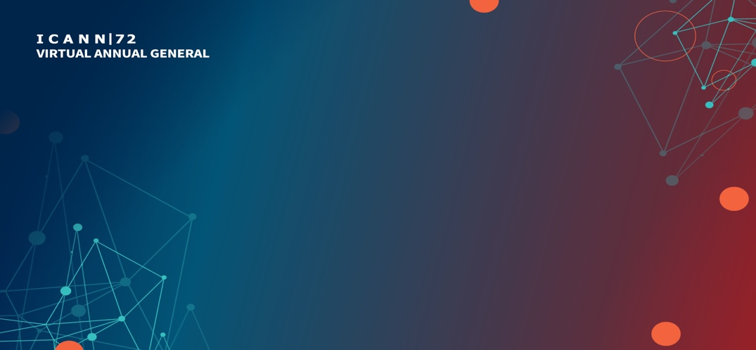

NextGen@ICANN72 Presentations

Open Session
Monday, 25 October– 17:30-19:00 UTC

Welcome to a rare opportunity to learn about the future of the Internet directly from the next generation of Internet leaders. Members of the NextGen@ICANN program will be delivering rapid-fire presentations that are 5-10 minutes in length. Each presentation showcases the impressive work being done by members of the program. Thank you for your support!
AGENDA

Introduction – Deborah Escalera, ICANN Staff overseeing NextGen@ICANN
Welcome - NextGen@ICANN Mentors

NextGen Presenters (Monday, 25 October)
Name | University
Sarah Alsamman | DePaul University
Meri Baghdasaryan | University Pennsylvania Carey Law School
Sai Prasad Chandrasekaran | Indiana University Bloomington
Kady Hammer | American University, Washington College of Law
Jung Seob Kim | Lamar University
James Paek | University of Georgia

NextGen Mentors
Aris Ignacio

Dessalegn Yehuala

